Solution: Creating New Entities

In this lab, you will use the Entity Editor to create a new entity.

Requirements

This lab requires that you use TrainingApp 8.0 and Guidewire Studio 8.0.

Overview

The fictitious Acme Insurance Company is your customer. Your job is to make the necessary changes to meet customer requirements.

Acme wants to capture specific information about each contact interaction such as a telephone call, email message, postal mail letter, or in-person office visit. Eventually, Acme wants the information displayed in an Interactions section of TrainingApp. The goal is to have customer service representatives such as Alice Applegate to create and edit details about contact interactions. For the time being, Acme wants you to implement the necessary data model changes.

1. Create an entity

In this exercise, you will use the Entity Editor to create an entity to capture contact interaction details. For each new entity element, remember to set the nullok attribute to true if not specifically defined to be false. When required, add an element description and specify column parameters.

Tasks

1. Open Guidewire Studio
2. From the bin folder, open a command window and start Guidewire Studio for TrainingApp.
3. Alternatively, use the Start TrainingApp Studio shortcut.
4. Create a new entity named Interaction_Ext
5. In Studio, in Project View, create the new entity named Interaction_Ext.  
   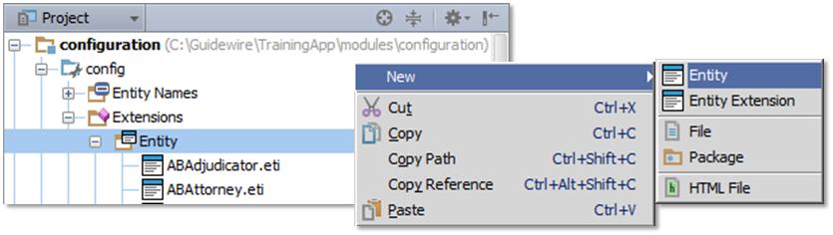  
   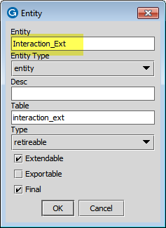
6. Add the following elements:

|  |  |  |
| --- | --- | --- |
| Element Name | Datatype | Nullok |
| ABContact | A foreign key to ABContact | false |
| InteractionDate | a date and time | true |
| InitiatedByContact | a boolean value | true |
| Summary | A string of up to 60 characters | true |
| AssociatedUser | A foreign key to User | true |

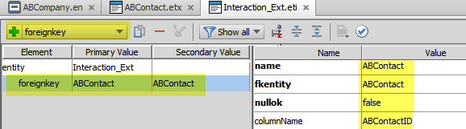

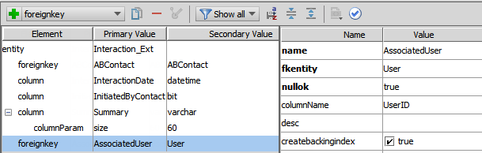

1. Validate your changes in the Entity Editor.

Write it down

Is the foreign key to ABContact required? Explain your answer.

|  |
| --- |
| Yes. Every interaction must involve an ABContact. |

1. Extend an entity to include an array

In this exercise, you will use Entity Editor to extend the ABContact entity. You will add an array element to associate the Interaction_Ext entity interactions with contacts. For each new entity element, remember to set the nullok attribute to true if not specifically defined to be false. When required, add an element description and specify column parameters.

Tasks

1. Edit ABContact to add an array
2. In Guidewire Studio, navigate to ABContact.
3. In the Entity Editor, create and configure an array of associated interactions on ABContact.  
   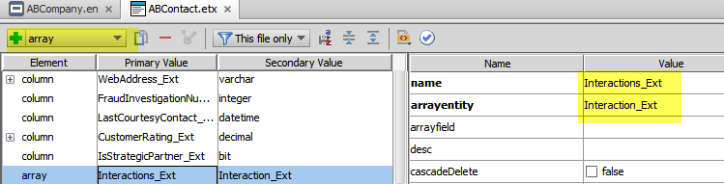
4. Validate your changes in the Entity Editor.

Optional verification

1. Build the data dictionary from the command window
2. From the bin folder, open a command window.
3. In the command window, enter the command to build the data dictionary.
4. Open the data dictionary
5. In Windows Explorer, navigate to the data dictionary.
6. Open the data dictionary using Internet Explorer.
7. View the ABContact entity
8. Verify each new field and associated datatype.

Deployment

1. Deploy your changes
2. From studio, restart the server using Debug 'Server'.
3. If open, review the Messages Make window for compilation errors.
4. Review the Debug console for errors.
5. Verify that the application is running in the Debug console.

|  |  |
| --- | --- |
|  | Stop and ask your instructor to review your completed lab. |